Aim of the project: I need to derive differentiator set of each mutant based on two different ways and then compare the results. The two ways are:

1. Based on Subsumption (Working on it)
2. Based on Equivalence (Pending)

I will focus on class Vt100TerminalModel.java and build the subsumption graph from this class mutants and tests.

LittleDarwin generates 94 mutants for Vt100TerminalModel.java out of which 31 are killed and 18 are subsumed. Below is screenshot of the analysis and the subsumption graph.

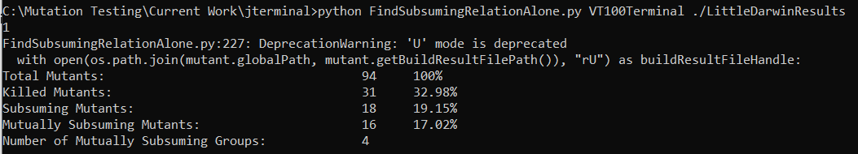

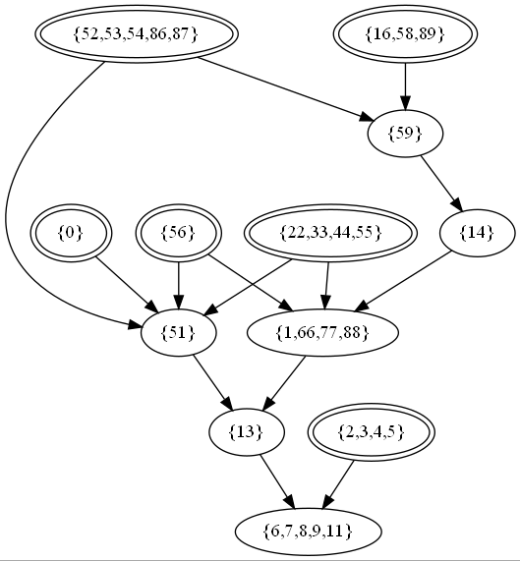

Deriving the DS Based on Subsumption:

1. Get one mutant from each maximal node as Mi: Based on the graph above, we can select 52, 16, 0, 56, 22, 2
2. Run test Tj forevery j on P and Mi for every i. if Output(Mi,Tj) != Output(P,Tj), Tj is in the DS(P,Mi) (Working on it)

**Based On Equivalence:**

The way to derive the minimal mutant set by equivalence can be done by:

1. Build a test suite T:
   1. T is either the one that comes by default with the program
   2. T is built manually
2. Run every test in T on every mutant in M
3. Compare the outputs of the mutants:
   1. If Output(m1,ti)=Output(m2,ti) for every i, then m1 and m2 are equivalent.
4. When to stop:
   1. Never stop until you compare all mutants
   2. Stop until I have 21 non-equivalent mutants
   3. Until I do 76 comparison